Artificial Neural Network

ECE 692

Mid-Term Project

Back-Propagation Algorithm with modifiable input, hidden and output layers.

**Design Document:**

Introduction:

The program is designed to recognize patterns for given inputs using the Back -Propagation Algorithm. The program takes three data sets for training, validation and tests respectively. The program can take ‘n’ number of inputs, hidden and output neurons to build modifiable the structure of the Artificial Neural Network. The output is stored in an excel from which data can be mapped to ROC curve and Confusion matrix tables for better understanding of the results.

Data Structures:

The program mainly uses vectors and templates. Exception handling has been implemented to counter unfavorable conditions.

Data Set:

The data set has been adopted from the **UC Irvine Machine Learning Repository**.

The information regarding the data set on the site is as follows.

1. Title: Wisconsin Diagnostic Breast Cancer (WDBC)

2. Source Information

a) Creators:

Dr. William H. Wolberg, General Surgery Dept., University of

Wisconsin, Clinical Sciences Center, Madison, WI 53792

wolberg@eagle.surgery.wisc.edu

W. Nick Street, Computer Sciences Dept., University of

Wisconsin, 1210 West Dayton St., Madison, WI 53706

street@cs.wisc.edu 608-262-6619

Olvi L. Mangasarian, Computer Sciences Dept., University of

Wisconsin, 1210 West Dayton St., Madison, WI 53706

olvi@cs.wisc.edu

b) Donor: Nick Street

c) Date: November 1995

3. Past Usage:

first usage:

W.N. Street, W.H. Wolberg and O.L. Mangasarian

Nuclear feature extraction for breast tumor diagnosis.

IS&T/SPIE 1993 International Symposium on Electronic Imaging: Science

and Technology, volume 1905, pages 861-870, San Jose, CA, 1993.

OR literature:

O.L. Mangasarian, W.N. Street and W.H. Wolberg.

Breast cancer diagnosis and prognosis via linear programming.

Operations Research, 43(4), pages 570-577, July-August 1995.

Medical literature:

W.H. Wolberg, W.N. Street, and O.L. Mangasarian.

Machine learning techniques to diagnose breast cancer from

fine-needle aspirates.

Cancer Letters 77 (1994) 163-171.

W.H. Wolberg, W.N. Street, and O.L. Mangasarian.

Image analysis and machine learning applied to breast cancer

diagnosis and prognosis.

Analytical and Quantitative Cytology and Histology, Vol. 17

No. 2, pages 77-87, April 1995.

W.H. Wolberg, W.N. Street, D.M. Heisey, and O.L. Mangasarian.

Computerized breast cancer diagnosis and prognosis from fine

needle aspirates.

Archives of Surgery 1995;130:511-516.

W.H. Wolberg, W.N. Street, D.M. Heisey, and O.L. Mangasarian.

Computer-derived nuclear features distinguish malignant from

benign breast cytology.

Human Pathology, 26:792--796, 1995.

See also:

http://www.cs.wisc.edu/~olvi/uwmp/mpml.html

http://www.cs.wisc.edu/~olvi/uwmp/cancer.html

Results:

- predicting field 2, diagnosis: B = benign, M = malignant

- sets are linearly separable using all 30 input features

- best predictive accuracy obtained using one separating plane

in the 3-D space of Worst Area, Worst Smoothness and

Mean Texture. Estimated accuracy 97.5% using repeated

10-fold crossvalidations. Classifier has correctly

diagnosed 176 consecutive new patients as of November

1995.

4. Relevant information

Features are computed from a digitized image of a fine needle

aspirate (FNA) of a breast mass. They describe

characteristics of the cell nuclei present in the image.

A few of the images can be found at

http://www.cs.wisc.edu/~street/images/

Separating plane described above was obtained using

Multisurface Method-Tree (MSM-T) [K. P. Bennett, "Decision Tree

Construction Via Linear Programming." Proceedings of the 4th

Midwest Artificial Intelligence and Cognitive Science Society,

pp. 97-101, 1992], a classification method which uses linear

programming to construct a decision tree. Relevant features

were selected using an exhaustive search in the space of 1-4

features and 1-3 separating planes.

The actual linear program used to obtain the separating plane

in the 3-dimensional space is that described in:

[K. P. Bennett and O. L. Mangasarian: "Robust Linear

Programming Discrimination of Two Linearly Inseparable Sets",

Optimization Methods and Software 1, 1992, 23-34].

This database is also available through the UW CS ftp server:

ftp ftp.cs.wisc.edu

cd math-prog/cpo-dataset/machine-learn/WDBC/

5. Number of instances: 569

6. Number of attributes: 32 (ID, diagnosis, 30 real-valued input features)

7. Attribute information

1) ID number

2) Diagnosis (M = malignant, B = benign)

3-32)

Ten real-valued features are computed for each cell nucleus:

a) radius (mean of distances from center to points on the perimeter)

b) texture (standard deviation of gray-scale values)

c) perimeter

d) area

e) smoothness (local variation in radius lengths)

f) compactness (perimeter^2 / area - 1.0)

g) concavity (severity of concave portions of the contour)

h) concave points (number of concave portions of the contour)

i) symmetry

j) fractal dimension ("coastline approximation" - 1)

Several of the papers listed above contain detailed descriptions of

how these features are computed.

The mean, standard error, and "worst" or largest (mean of the three

largest values) of these features were computed for each image,

resulting in 30 features. For instance, field 3 is Mean Radius, field

13 is Radius SE, field 23 is Worst Radius.

All feature values are recoded with four significant digits.

8. Missing attribute values: none

9. Class distribution: 357 benign, 212 malignant

**Attribute Information:**

1) ID number   
2) Diagnosis (M = malignant, B = benign)   
3-32)   
  
Ten real-valued features are computed for each cell nucleus:   
  
a) radius (mean of distances from center to points on the perimeter)   
b) texture (standard deviation of gray-scale values)   
c) perimeter   
d) area   
e) smoothness (local variation in radius lengths)   
f) compactness (perimeter^2 / area - 1.0)   
g) concavity (severity of concave portions of the contour)   
h) concave points (number of concave portions of the contour)   
i) symmetry   
j) fractal dimension ("coastline approximation" - 1)

**The attributes 3-32 are used as inputs and the attribute 2 is used as output after mapping M=1 and B=0.**

**User Document:**

Steps to run the program:

1. Unzip the file
2. Open the ‘Backpropagation_Jigar.sln’ file in Visual Studio 2017( MVSC running on Windows 10 SDK version 10.0.17763.0)
3. 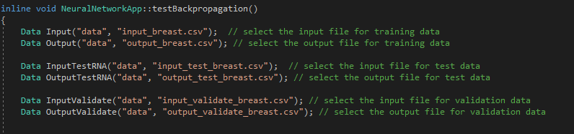Select the input and output files for training, test and validation.
4. 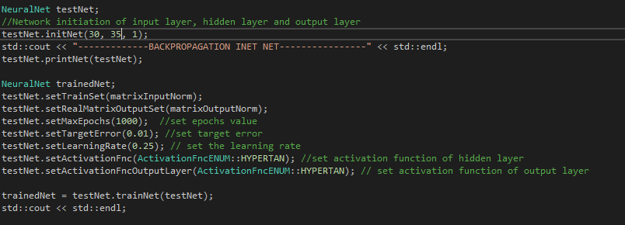Select the number of input, hidden and output layers.
5. Run the main.cpp file
6. After successfull run check for the outfiles in results folder.

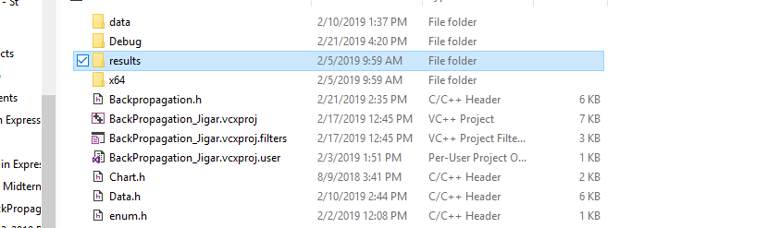

**References:** https://archive.ics.uci.edu/ml/datasets/Breast+Cancer+Wisconsin+(Diagnostic)